Folding Windshield Hold Down Instructions
On the Rox Fabrication
Ontheroxfab.com
406-967-2189

*READ INSTRUCTIONS THOUROUGHLY BEFORE BEGINNING. OTR IS NOT RESPONSIBLE FOR INCORRECT INSTALLATION OR LOCAL LAWS REGARDING AFTERMARKET ACCESORIES. THE USER IS RESPONSIBLE FOR ALL LIABILITIES ASSOCIATED WITH THE INTSALLATION AND USE OF THIS PRODUCT.
ALWAYS UTILIZE PERSONAL SAFETY EQUIPMENT WHEN YOU ARE WORKING IN THE SHOP.
DISCONNECT BATTERY BEFORE YOU BEGIN.
- First, begin by measuring and finding the center of the hood. Do not use the hinges as their mounting location may vary. Use a body line on the hood.
- Use masking tape to mark the center, and the upcoming measurements as you make them.

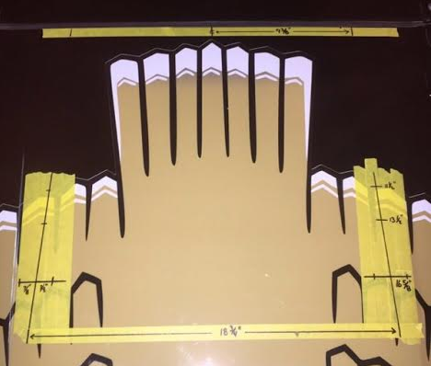
- From the center, mark 9 3/8” outwards on both sides.
- Use a framing square to map and mark out the rest of the holes as shown below. Make sure to align the framing square with the back edge of the hood (not the cowl) and use the back edge of the hood for reference as you mark out the remailing holes.
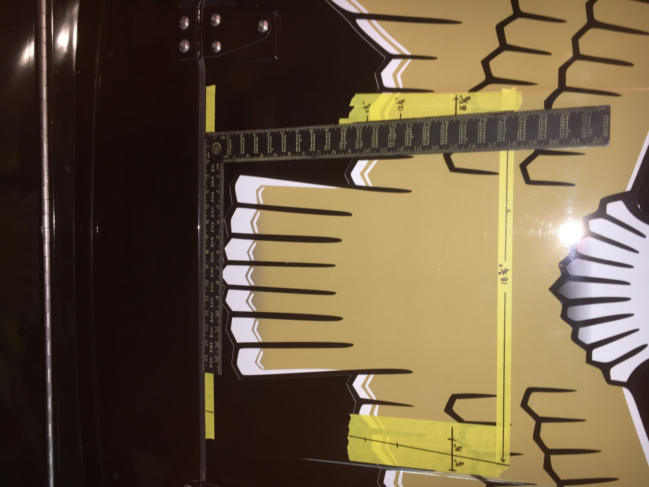
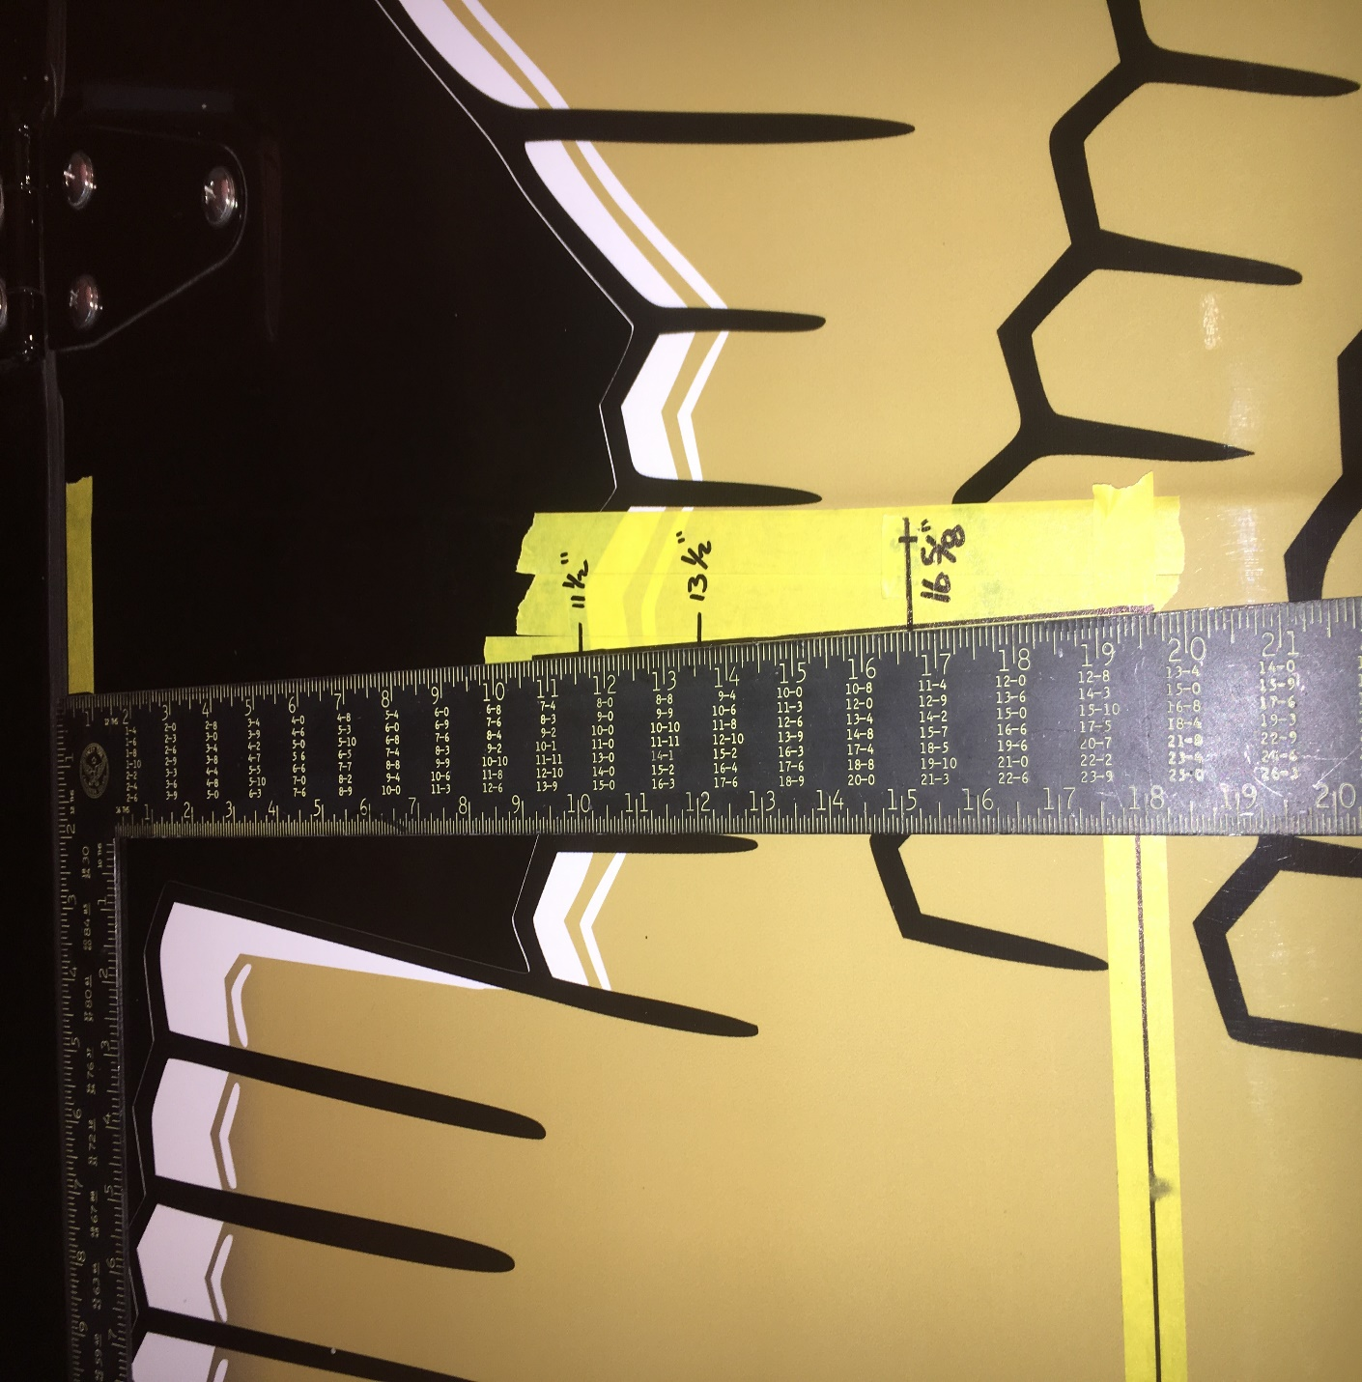
- Mark the next holes out at 11 ½”, 13 ½” and make a perpendicular mark at 16 5/8”.
- At 16 5/8” you will make two hole marks 7/8” on each side of the vertical line, on your perpindicular line as shown below.

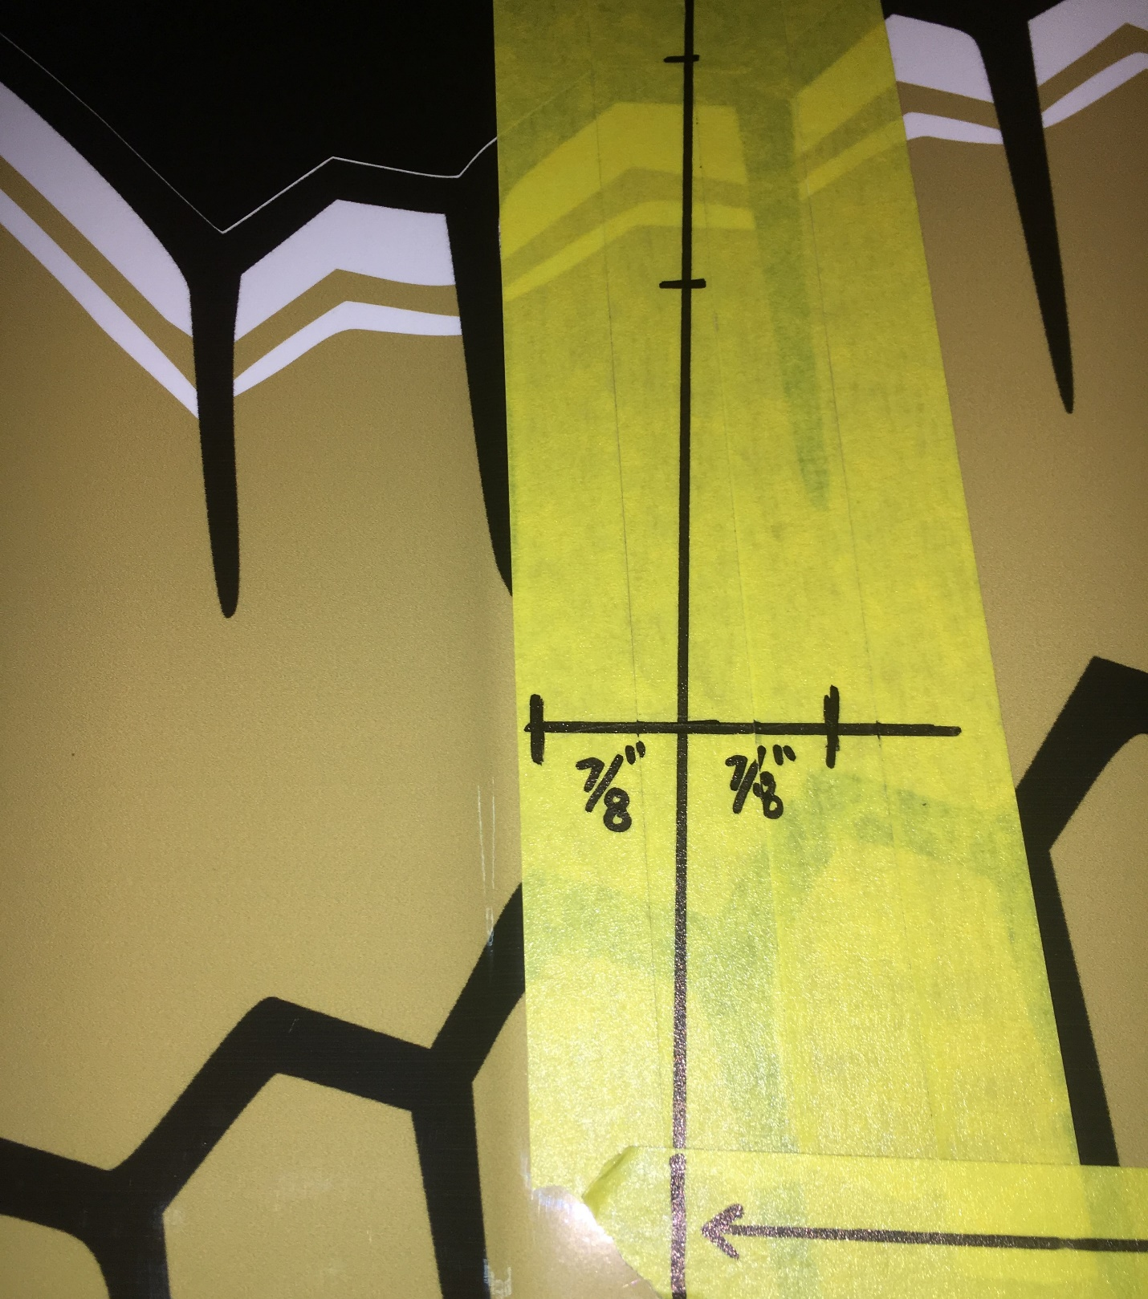
- Your map of measurements and holes to drill should look the same as below.

- Verify that your hole sets are 18 ¾” apart.
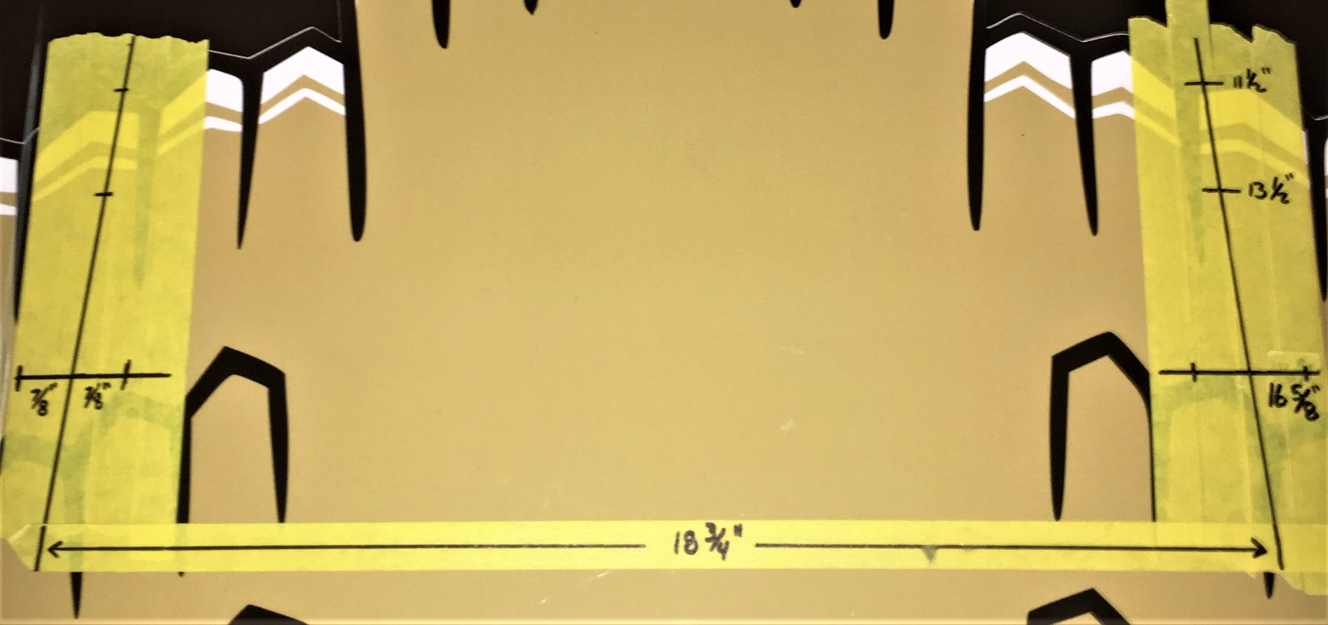
- Once all measurements are verified, drill the holes out with a ¼” drill bit. MAKE SURE NO OBJECTS IN THE ENGINE BAY WILL BE HIT WITH YOUR DRILLBIT.

- You may now mount the hold down hardware in the locations as shown below with the included hardware.

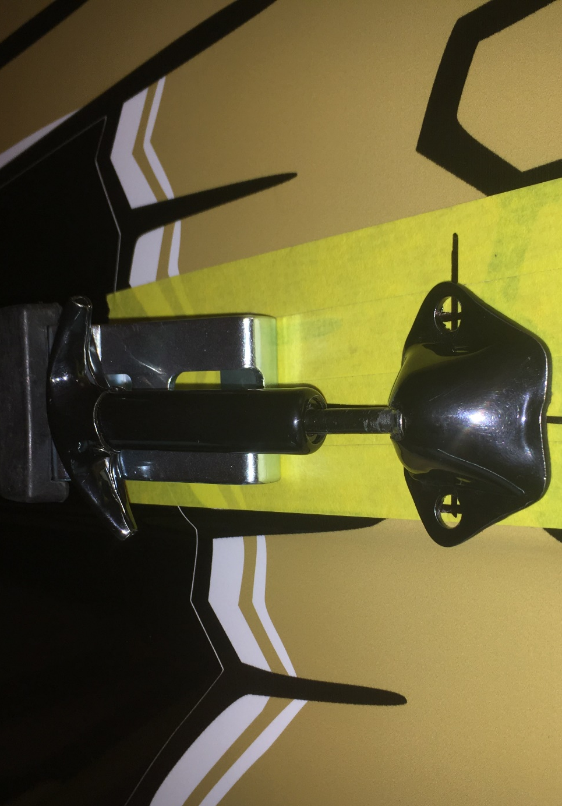
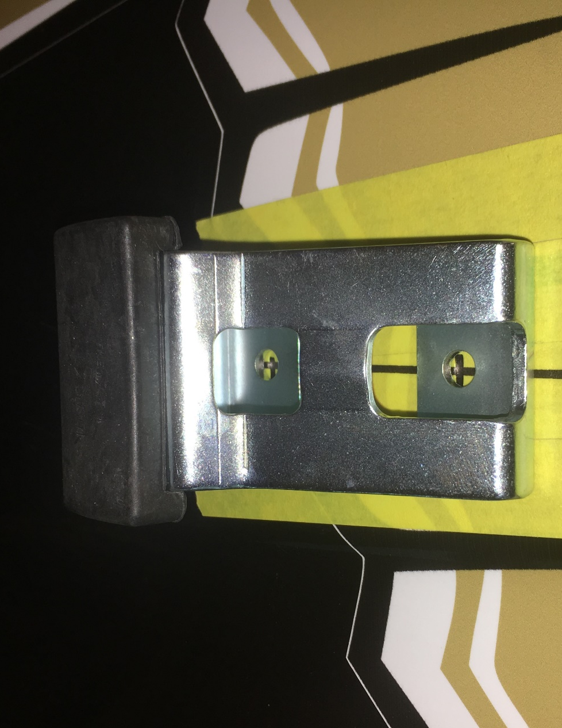

- Now, install the mounting tab onto the top of the folding windshield. Earlier models may require the holes to be drilled. Make sure the mounting tab will line up with the bumpers on the hood when the windshield is folded down. Image shown below.
